New Delhi, India

October 9, 2024

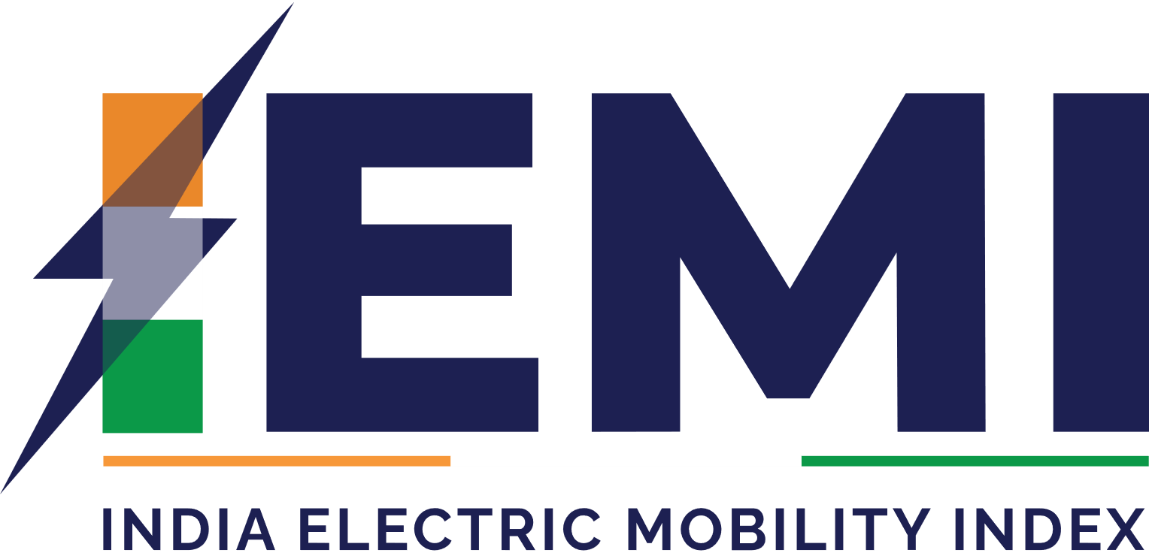

USER INTERFACE GUIDE

*India Electric Mobility Index (IEMI)*

Table of Contents

1.0 INTRODUCTION 3

2.0 LANDING PAGE 4

2.0 HOME PAGE 5

3.0 EXPLORE INDEX 7

4.0 STATE PROFILE 9

5.0 COMPARE STATES 11

6.0 TOOLS AND ANALYSES 13

7.0 DOWNLOADS 14

8.0 CONTACT US 15

# 1.0 INTRODUCTION

The Web Portal for **India Electric Mobility Index** is developed as a web-based portal to provide a comprehensive and ongoing evaluation of e-mobility development and also aims to identify key factors that will facilitate effective outcomes, paving the way for the development of a predictive model capable of forecasting future performance and growth across various outcome parameters. This web-based portal consists of the two applications – User Interface and Data Manager.

This user guide is developed to help the users to understand how to use user interface application of the IEMI. Below is the list of modules of the user interface application.

* 1. Home
  2. Explore Index
  3. State Profile
  4. Compare States
  5. Tools and Analyses
  6. Downloads
  7. Contact Us

Let us understand each of these modules and submodules in detail in the following chapters.

# 2.0 LANDING PAGE

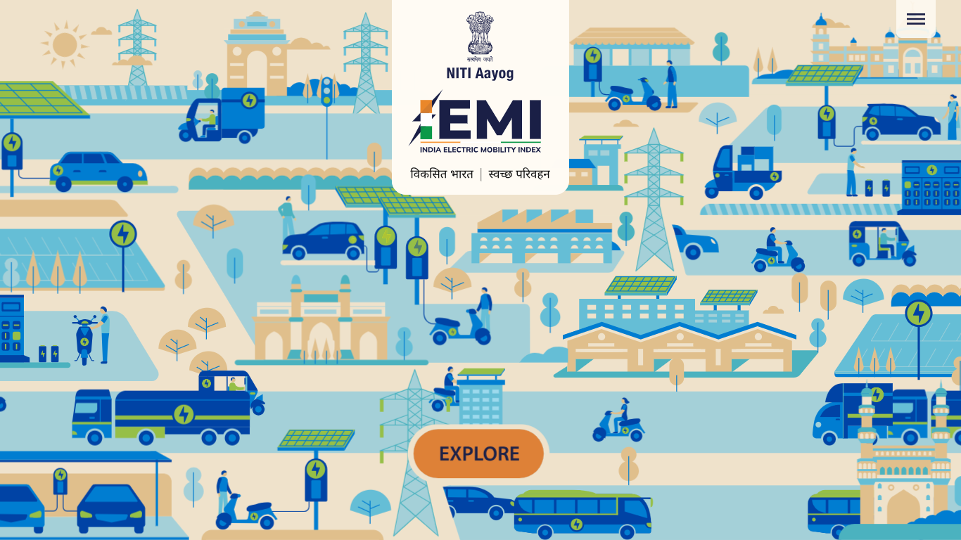The user interface application can be accessed through a web browser (recommended browser - Google Chrome latest version). Enter URL <https://iemi.itechmission.org/dashboard/home> in the web browser You will be navigated to the landing page of the web portal (see below figure).

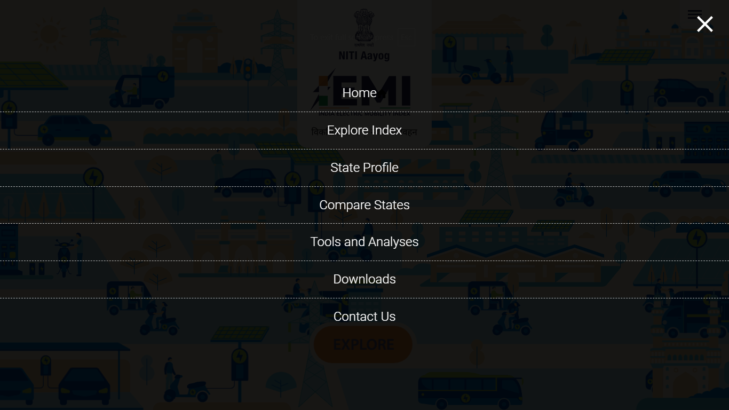The landing page features animated infographics that visually represent concepts related to electric mobility, along with Niti Aayog and project logo in the center. There is a Burger Menu at the top right corner that allows navigation to the other modules of the portal (see below figure).

Click on the **Explore** option available at the bottom of page to navigate to the home page of the portal.

# 2.0 HOME PAGE

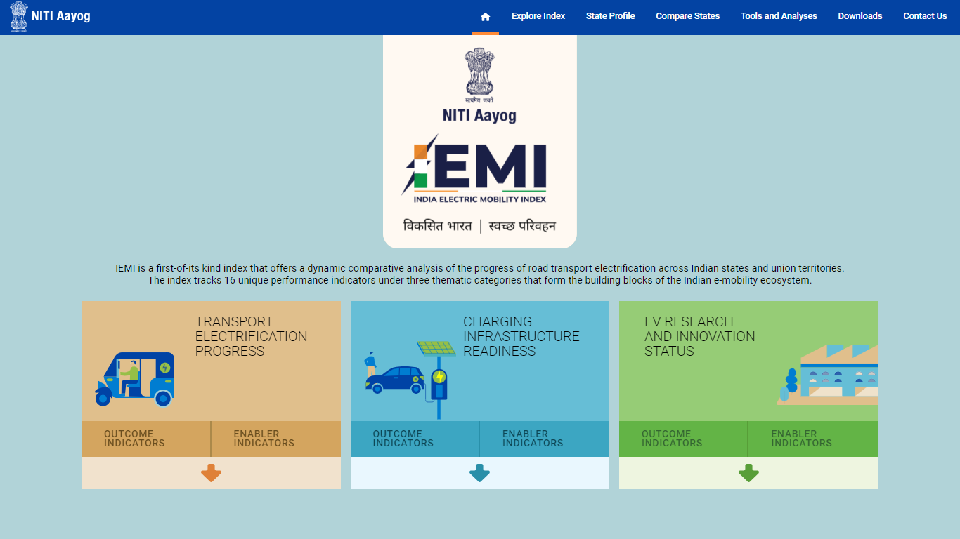The **Home** page contains the Niti Aayog logo along with the portal logo. It presents the information about the IEMI portal and introduces to the three thematic categories and its key performance indicators that form the building blocks of the Indian e-mobility ecosystem (see below figure).

The three themes are presented in separate boxes along with a related infographics. Each box contains the list of Outcome and Enabler indicators of the respective theme. Click on the **Arrow** icon to expand the list and view the complete list of key outcome and enabler indicators (see below figure).

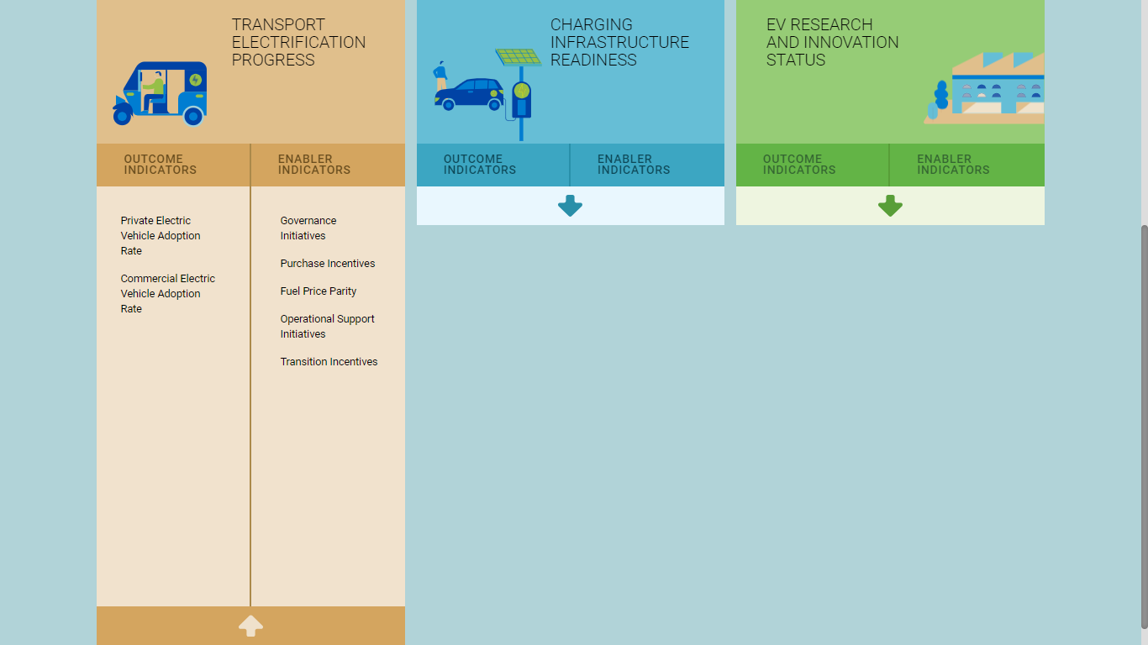You can hover on the indicators to read more about the respective indicator. Click on the theme name to navigate to the “**Explore Index**” module and view data for the same.

# 3.0 EXPLORE INDEX

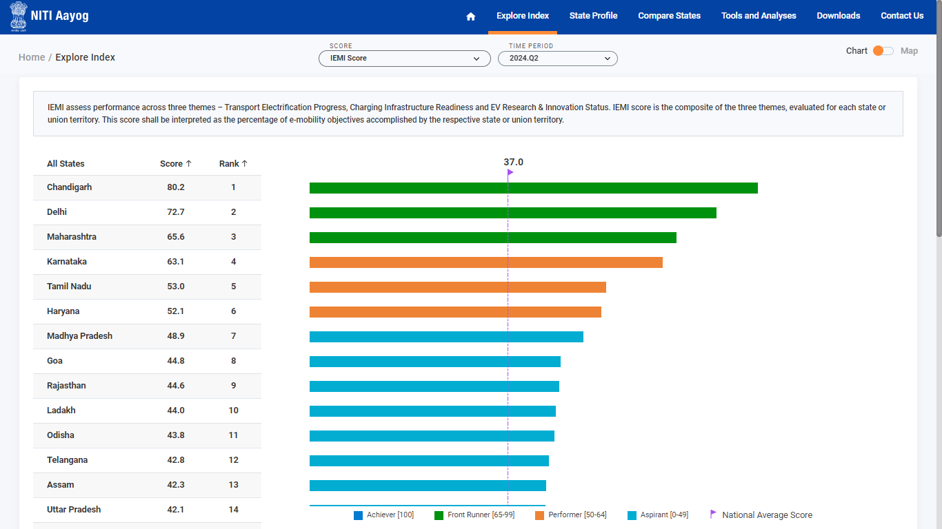Click on the **Explore Index** menu option available in the top header to access this module. This module is score and time period driven. It allows authorized users to view India’s electric mobility index data presented in visualizations. By default, IEMI Score of all states is shown of the most recent time period using the bar chart visualization (see below figure).

The legend for the data is presented at the bottom of the chart, which will help you understand the data and the range of data values. Click on the toggle button available at the top right corner to switch to the map view and view the selected data on the color theme map of India (see below figure).

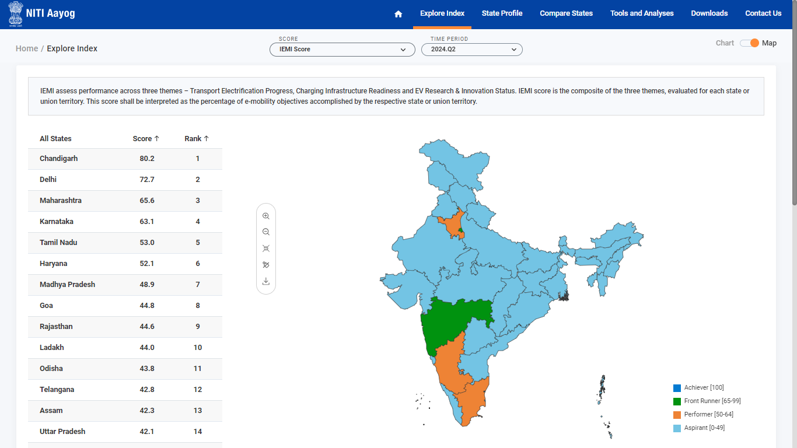There is a map toolbar available to the left side of the map which allows to perform the following actions –

Zoom in

Zoom out

Reset

Label on/off

Download

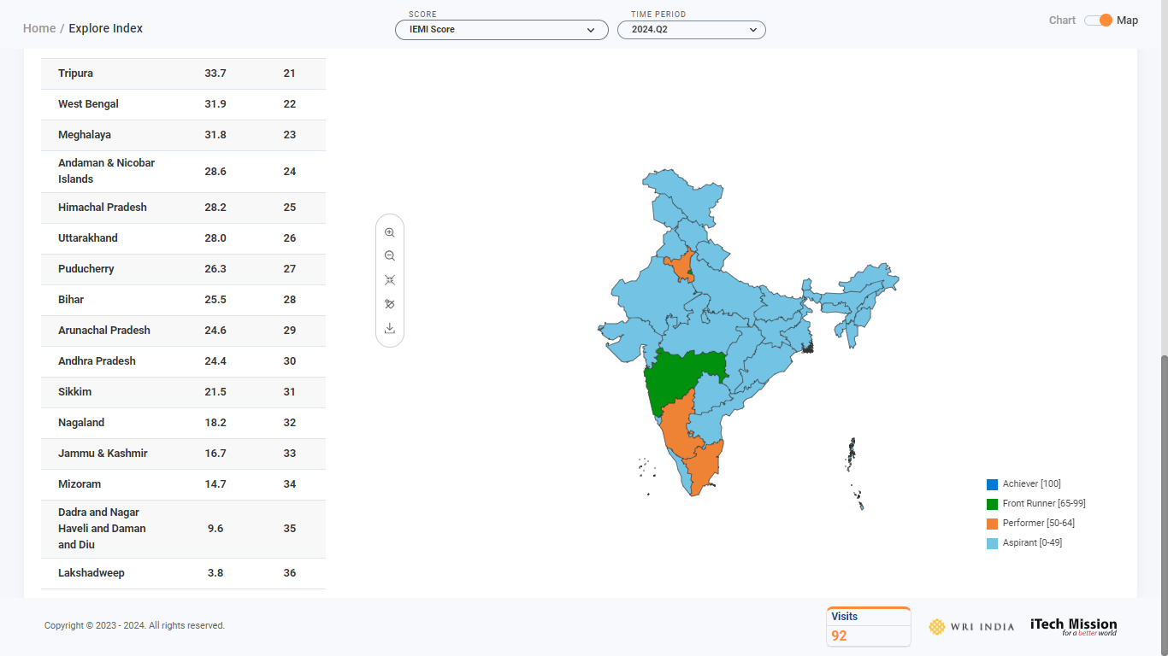You can also view the number of visits on the site at the bottom of the page along with the other logos of the portal (see below figure).

Click on the state area from map to navigate to the State Profile of the selected state.

# 4.0 STATE PROFILE

Click on the **State Profile** option from the navigation menu available in the header section to navigate to this module. This module is Area and Time period driven where area refers to the State and Union Territories of India. This module provides a comprehensive overview of the state's progress in electric vehicle (EV) adoption and infrastructure development. It allows users to view key metrics such as rankings, scores, and performance across critical themes like Transport Electrification Progress, Charging Infrastructure Readiness, and EV Research and Innovation Status.

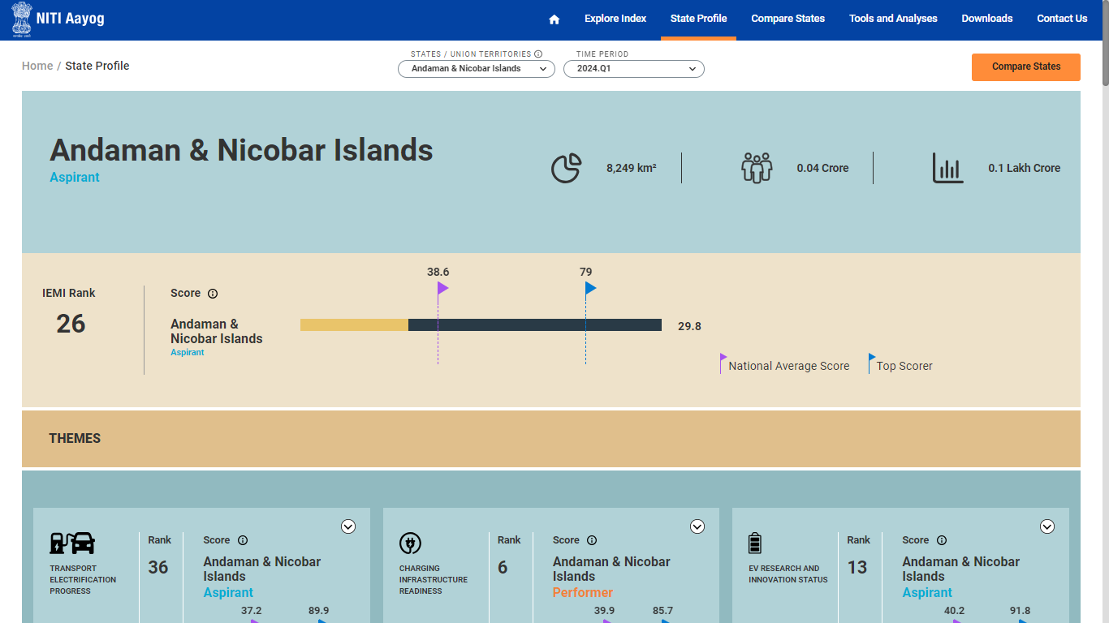By default, state profile of Andaman & Nicobar Islands is presented (see below figure).

Click on the **States & Union Territories** dropdown to select any other state and view its profile. Each state profile displays the following information -

1. **Overview**

* Area, population, and GDP of the state.
* IEMI rank and score based on overall performance.

1. **Key Themes and Rankings**

* Ranking and score compared to the national average and top scorers.
* Ranking and score for charging infrastructure development.
* Ranking and score for EV-related research and innovation activities.

1. **Outcomes**

* Progress in adopting electric vehicles.
* Number of charging stations and chargers available.
* Number of EV startups and active patents in the state.

1. **Key Initiatives**

Overview of policies and incentives related to transport electrification, charging infrastructure, and research and innovation.

1. **Highlights & USPs**

Notable regulations or policies, such as penalties for improper disposal of EV batteries

1. **Recommendations**

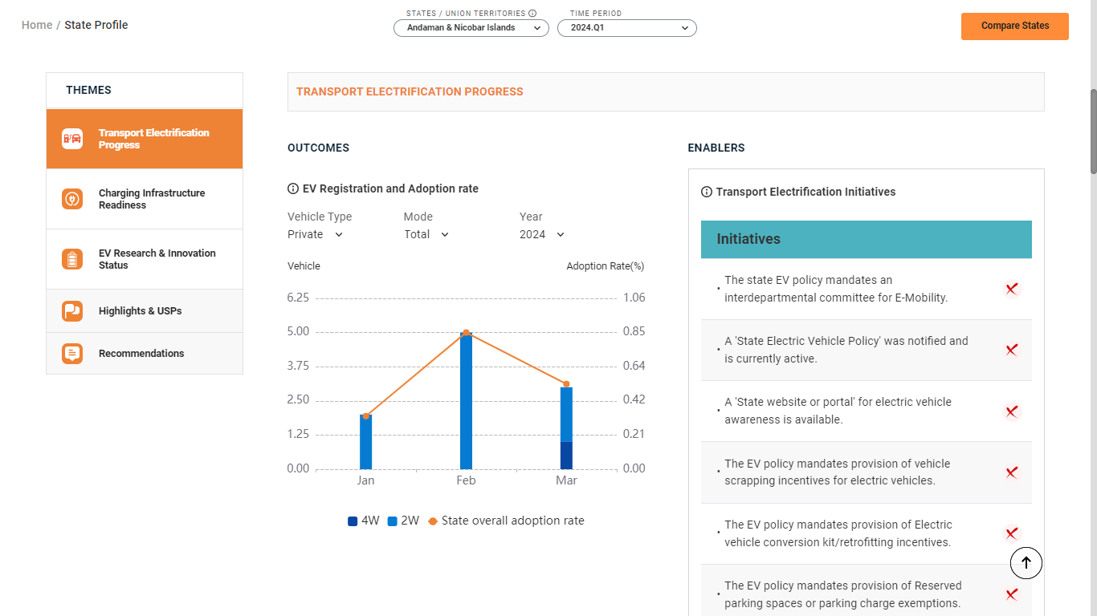Suggestions for improving transport electrification, charging infrastructure, and EV research and innovation based on current performance.

Click on the **Compare States** option available at the top right corner of the module or from the navigation menu to compare the profile of up to 3 states.

# 5.0 COMPARE STATES

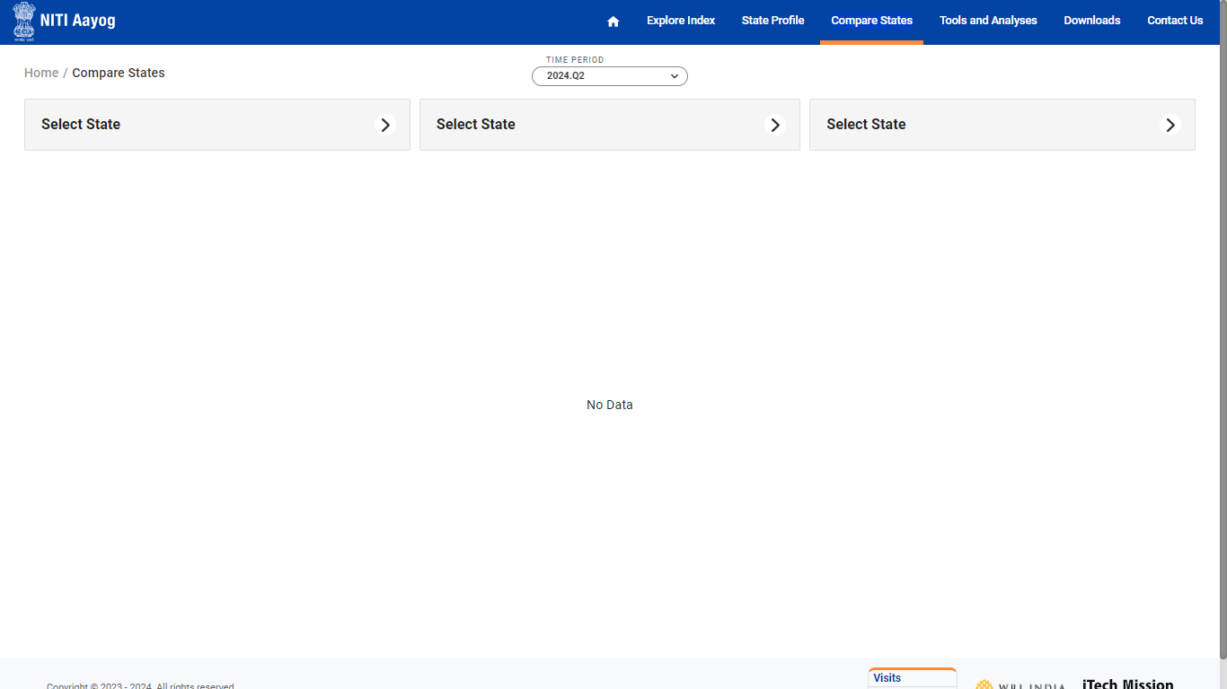Click on the **Compare States** option from the navigation menu available in the header section to navigate to this module. This module is Area and Time period driven where area refers to the State and Union Territories of India. This module allows to compare the state profile data of up to three states simultaneously which provides a side-by-side comparison of key metrics across all themes. You have to option to select states by clicking on the **Select State** option (see below figure).

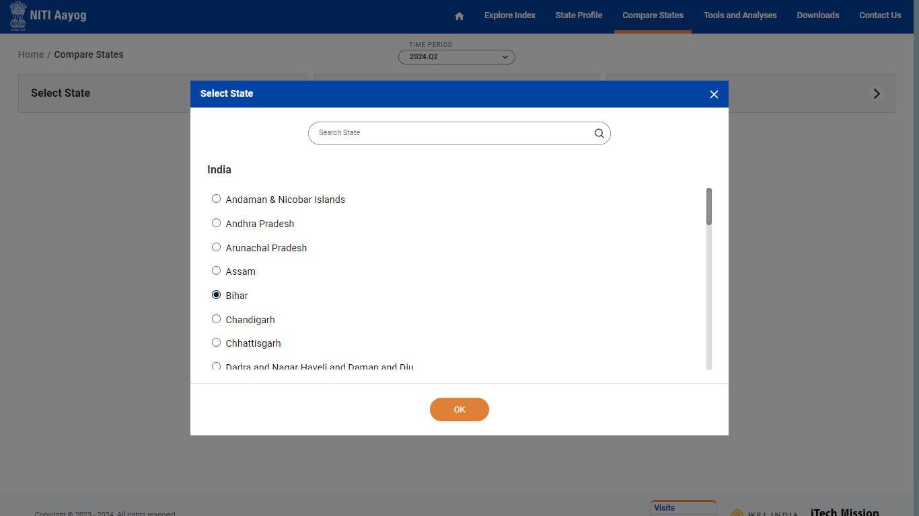A pop will appear with the list of all the states and UTs. You can search and select one of the state from the list. Click on the Ok button to confirm (see below figure).

Similarly select the other two states to compare the data.

The comparison data of the selected states will be presented for the selected time period. You can click on the Cross icon available with each state name to remove the selected state (see 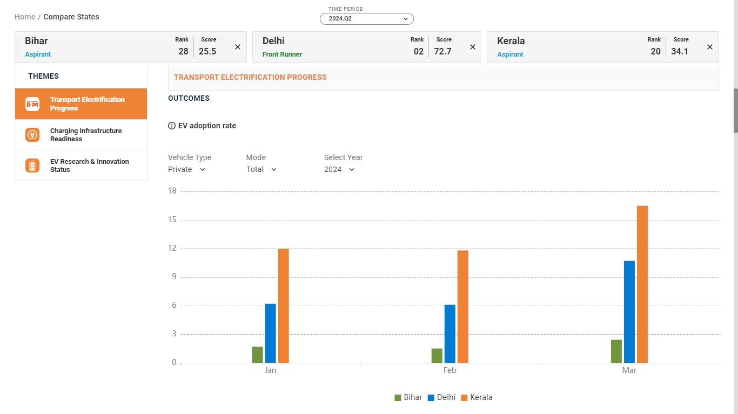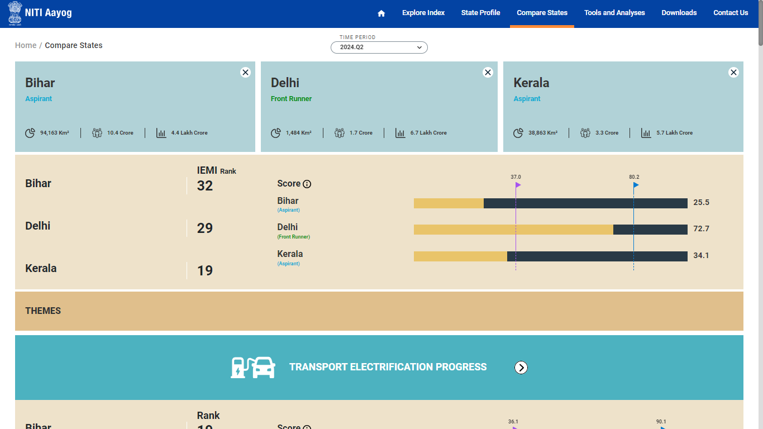below figure).

# 6.0 TOOLS AND ANALYSES

Click on the **Tools and Analyses** option from the navigation menu available in the header section to navigate to this module. This module serves as a comprehensive resource hub that will provide you the access to various tools and analytical resources focused on electric mobility. This module allows you to navigate through multiple pages, each offering detailed insights and calculations of the related categories. Below are the available categories that you can explore –

1. Total Cost of Ownership
2. Electric Vehicle Market Insights
3. Electric Vehicle Charging Tools
4. E-Buses in State Transport Undertakings
5. 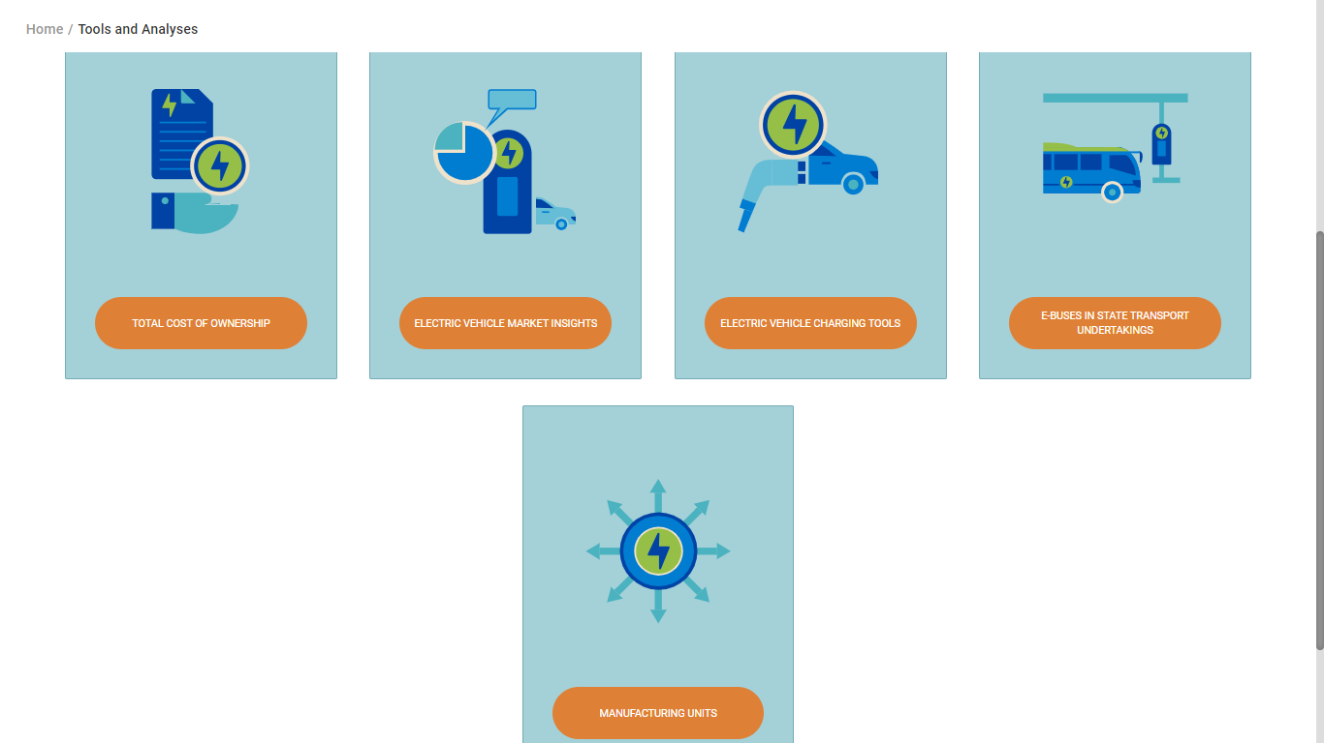Manufacturing Units

# 7.0 DOWNLOADS

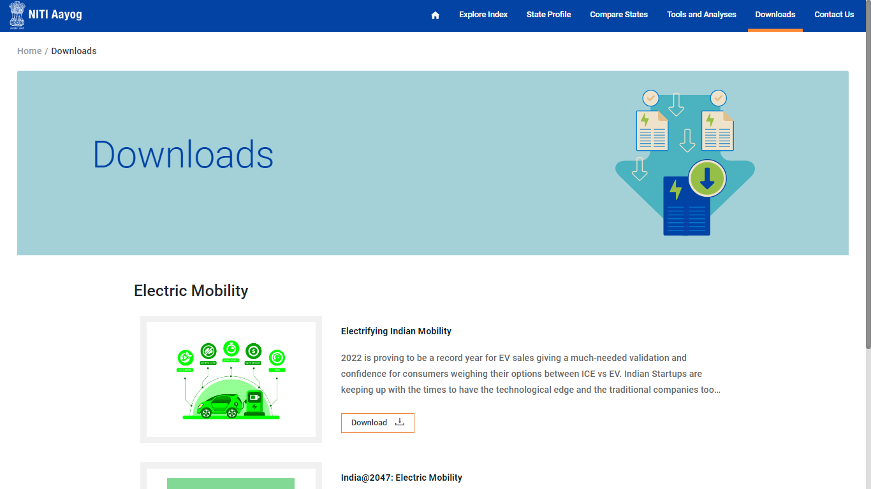Click on the **Downloads** option from the navigation menu available in the header section to navigate to this module. This module serves as a repository of resources and publications related to electric mobility in India. This module allows you to access the documents that provide insights into the current landscape, trends, and future projections of the electric vehicle (EV) industry (see below figure).

Click on the **Download** button available with each resource to download the related document locally.

# 8.0 CONTACT US

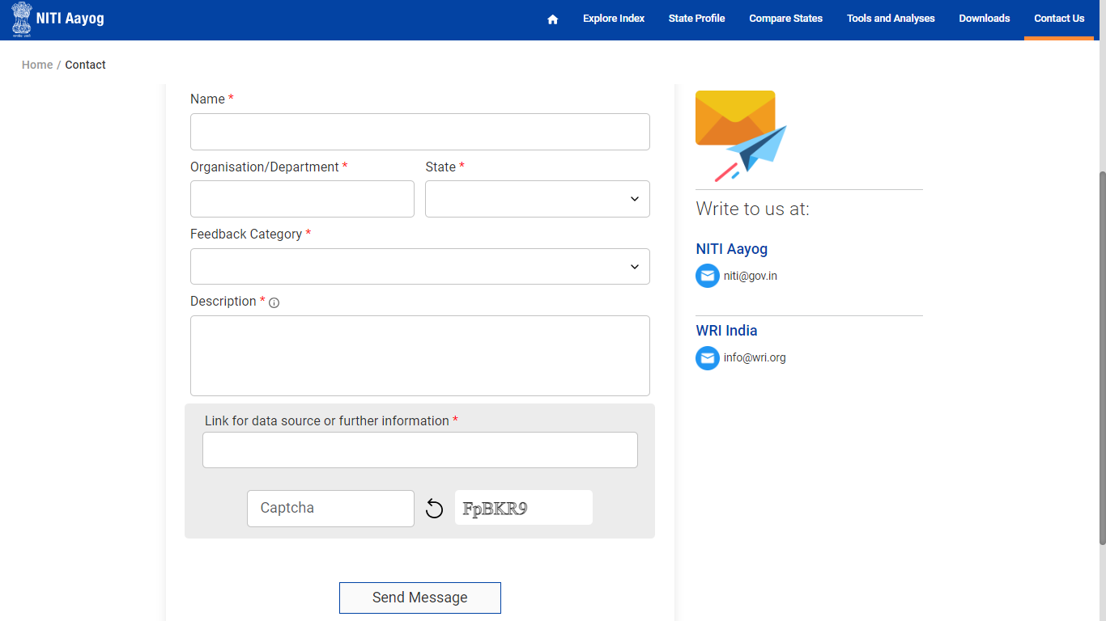Click on the Contact Us option from the navigation menu available in the header section to navigate to this module. This module allows you to communicate with the authorities regarding inquiries, feedback, or requests for additional information related to electric mobility initiatives. It features a user-friendly contact form where you can input the mandatory details and send your enquiry (see below figure).

Enter the following details to send your message/enquiry –

1. Name
2. Organization/Department
3. State
4. Feedback Category
5. Description
6. Link for Data Source or Further Information (optional)

A **Captcha** verification will be required to confirm that the submission is made by a human. After filling out the form, click the **Send Message** button to submit your inquiry.

**-----END OF THE DOCUMENT-----**